Nicholas Pittman

CS 443

Program 1 Report

14 February 2023

Table of Contents

**Original Image2**

**Quantized Images3**

**App Screenshot6**

**uniformQuant.m Source Code7**

**uniformQuantGUI.m Source Code8**

Figure 1: Unmodified 24-bit Image



Figure 2: Image quantized to bit depth of [3, 3, 2]

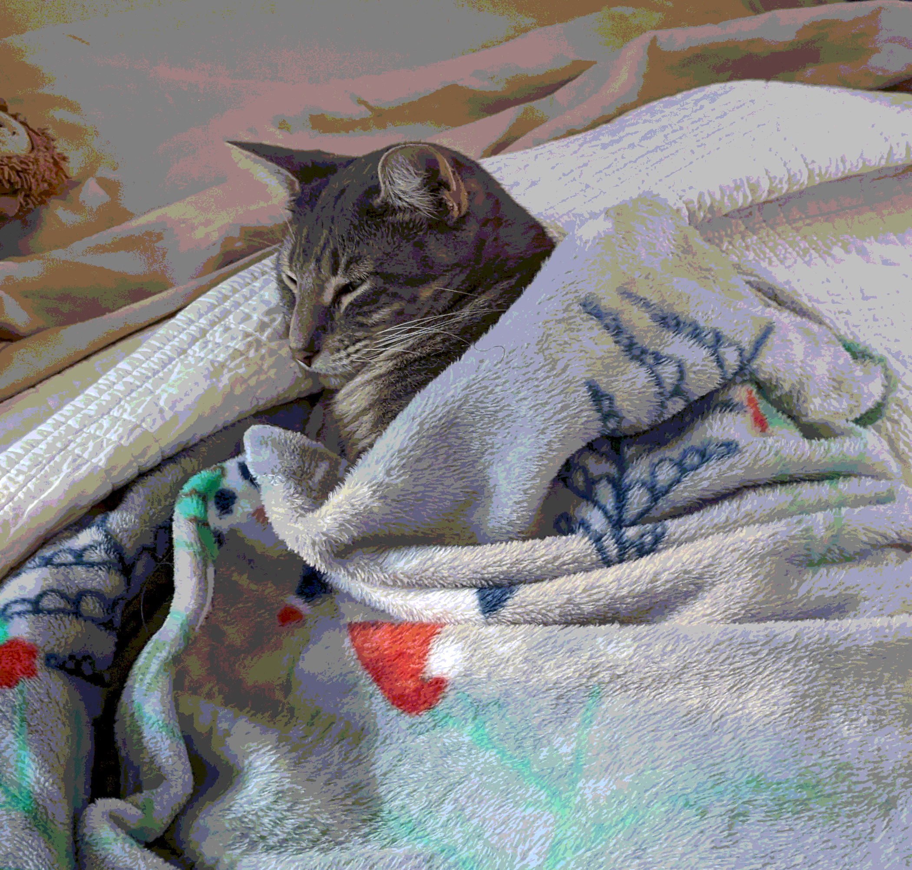

Figure 3: Image quantized to bit depth of [4, 2, 2]

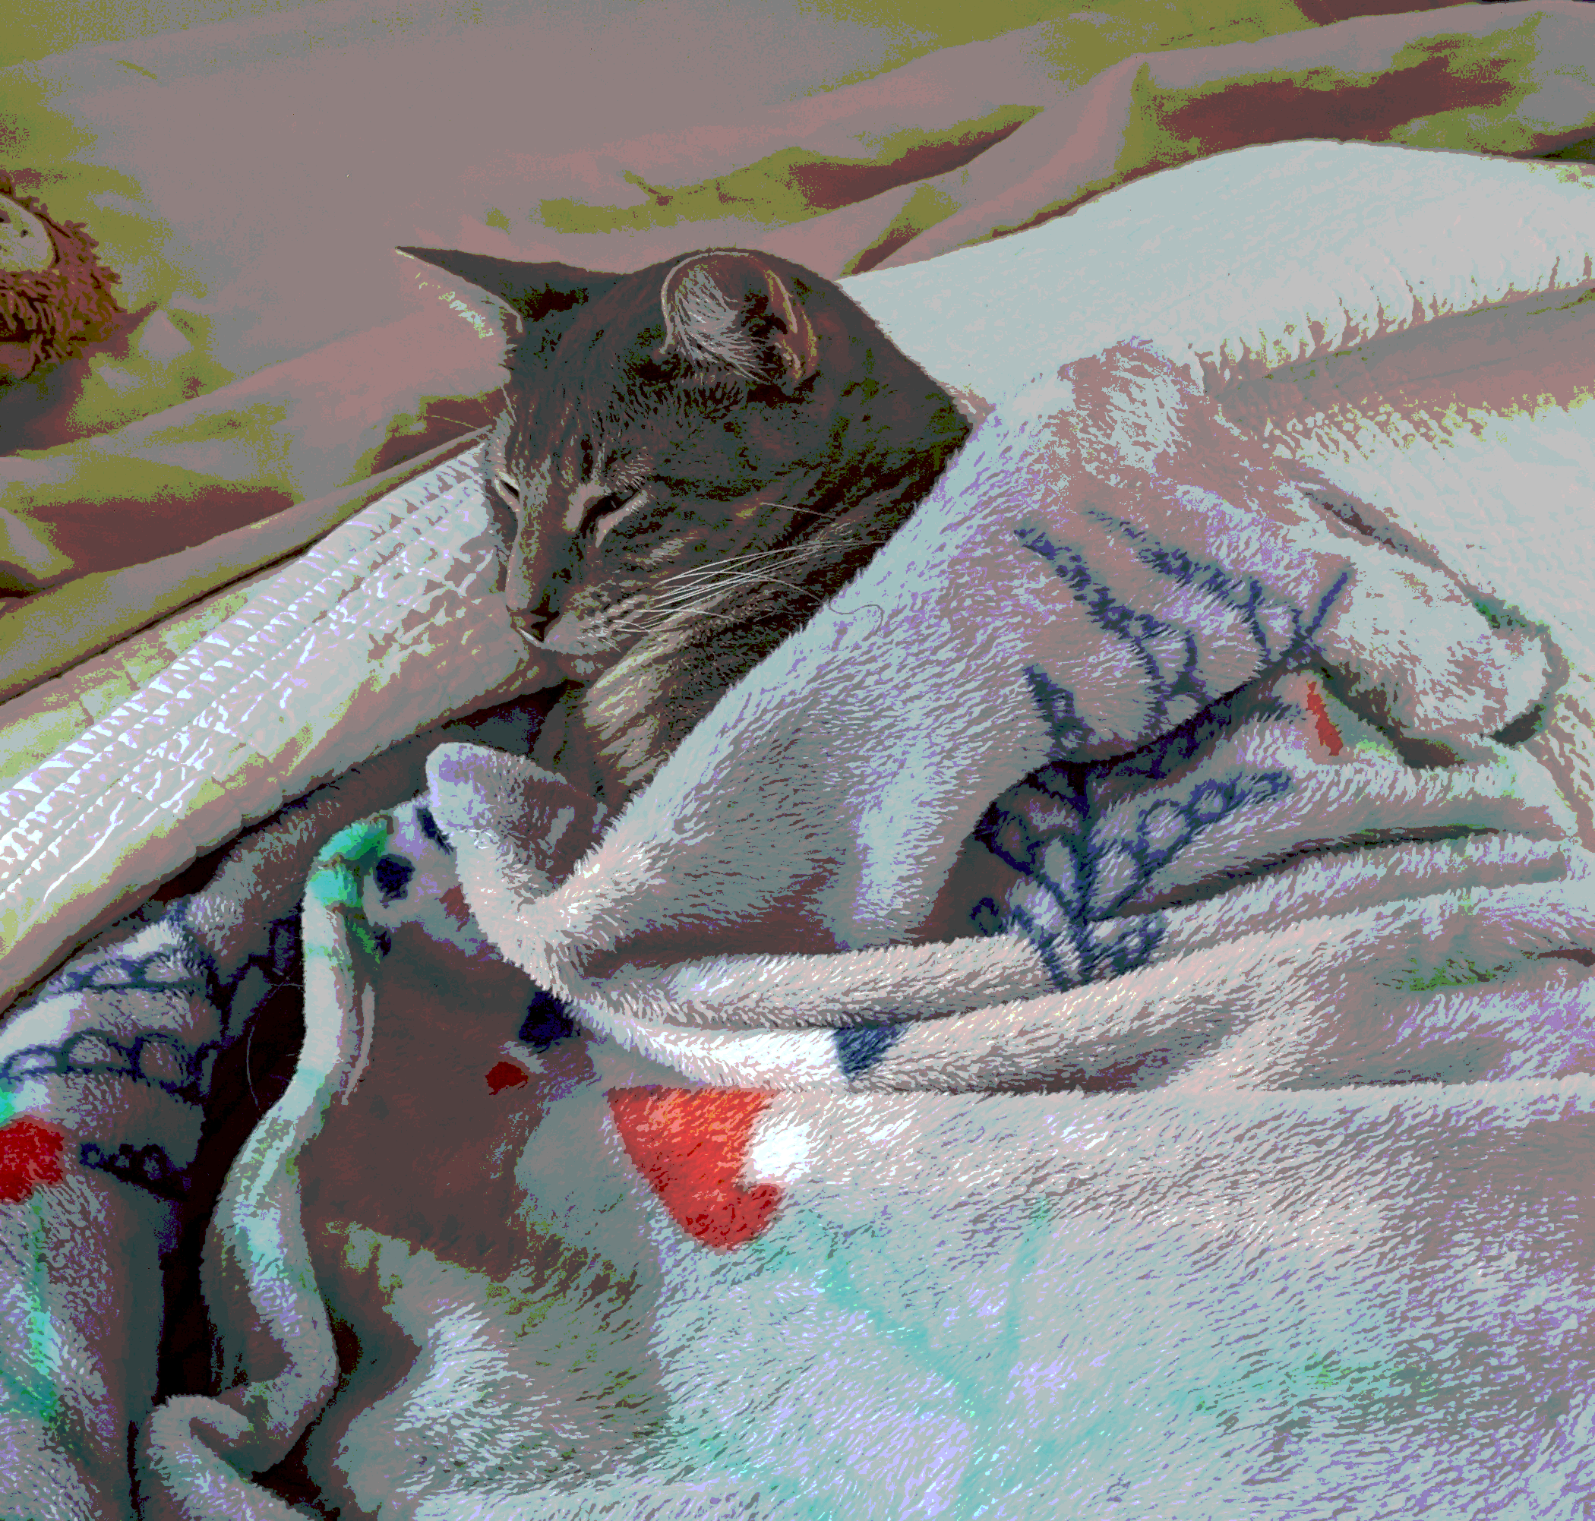

Figure 4: Image quantized to bit depth of [2, 2, 2]

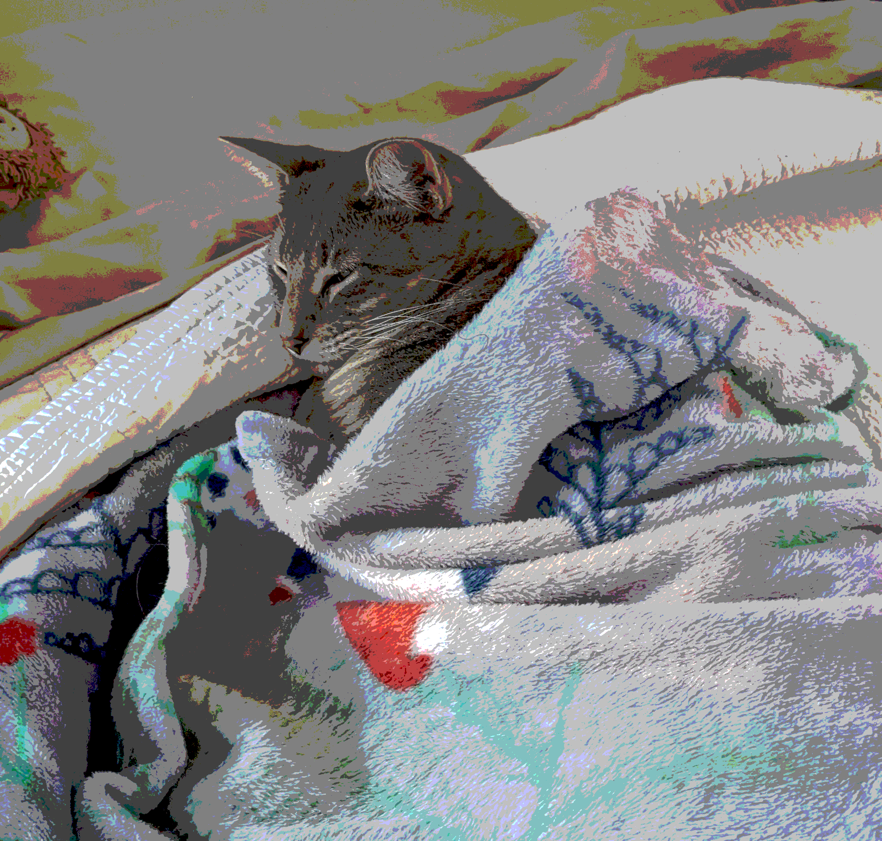

Figure 5: Screenshot of app in action

